**CHATING THE COURSE OF INNOVATION: STARTUP ANALYSIS**

1.INTRODUCTION

The analysis typically involves gathering information from a variety of sources, including stakeholders, subject matter experts, and industry data. This includes reviewing existing documentation, conducting interviews with key individuals, and gathering data and metrics relevant to the project.

The purpose of start analysis is to create a comprehensive understanding of the project, its risks, and its costs and benefits. This helps project managers make informed decisions about how to proceed, and helps them plan and budget for the project with greater accuracy and confidence.

**1.1 overview**

By understanding the project's goals and objectives, stakeholders can create a plan that is aligned with these requirements and minimizes the risk of failure. Additionally, effective start analysis can help identify potential challenges early on and allow for proactive mitigation measures to be taken.

In summary, effective start analysis is a vital component of project management that helps ensure successful project outcomes by providing a comprehensive overview of requirements and potential obstacles.

**1.2 purpose**

It involves:

Gathering and reviewing project requirements

Conducting market research to understand industry trends and competition

Analyzing the project's potential risks and opportunities

Creating a project plan and budget

Building a project team and assigning roles and responsibilities

Conducting a stakeholder analysis and developing a communication plan

Involving relevant stakeholders in the decision-making process.

PROBLEM DEFINITION & DESIGN THINKING

2.1 EMPATHY MAP :

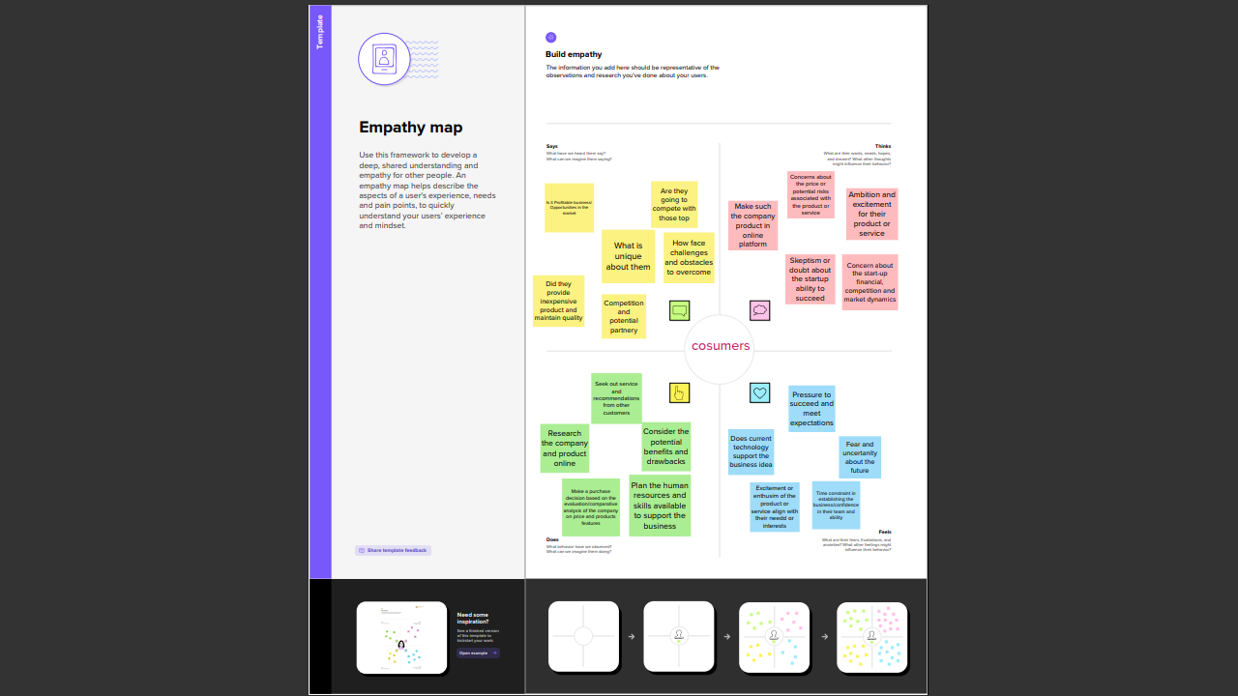

2.2 IDEATION & BRAINSTROMING MAP SCREENSHOT:

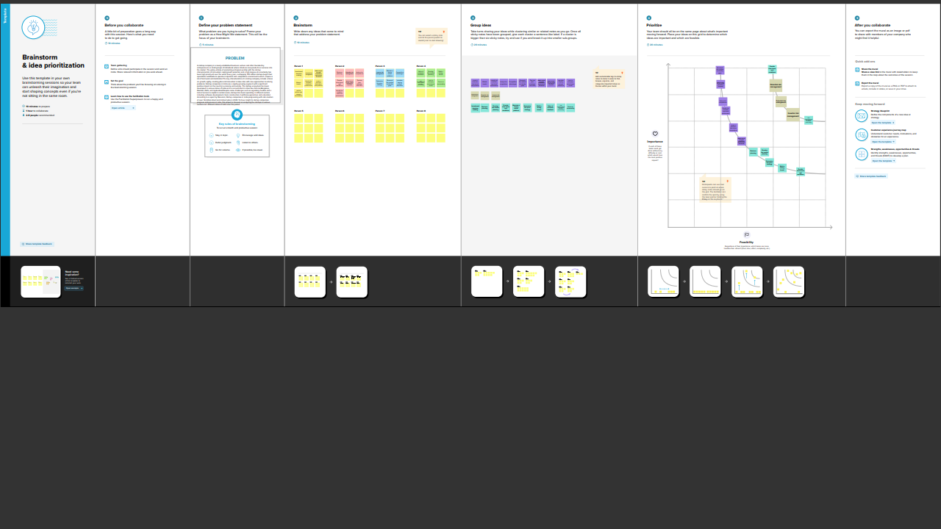

3.RESULT

1. Dashboard of the startup analysis project

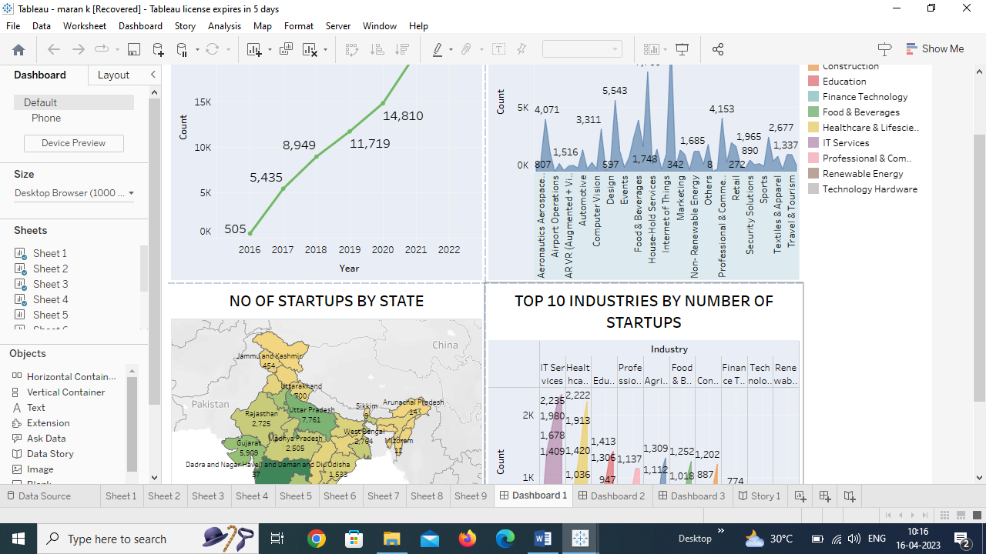

2.web integration of the startup analysis

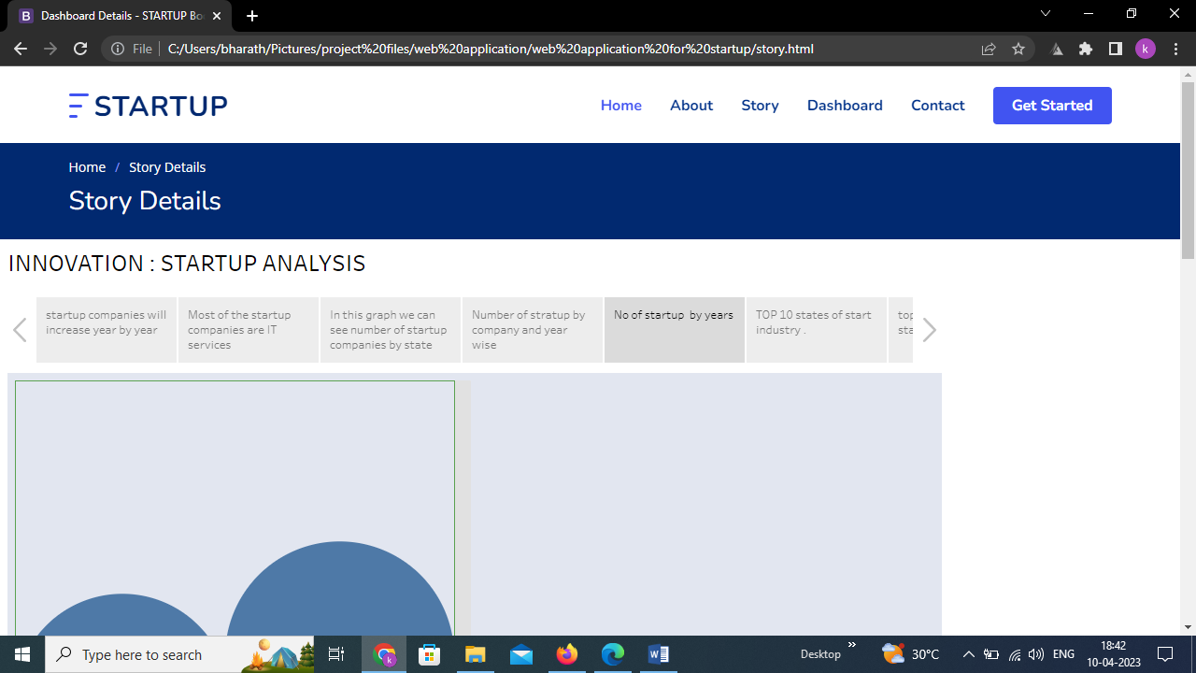

3.story of the startup analysis project

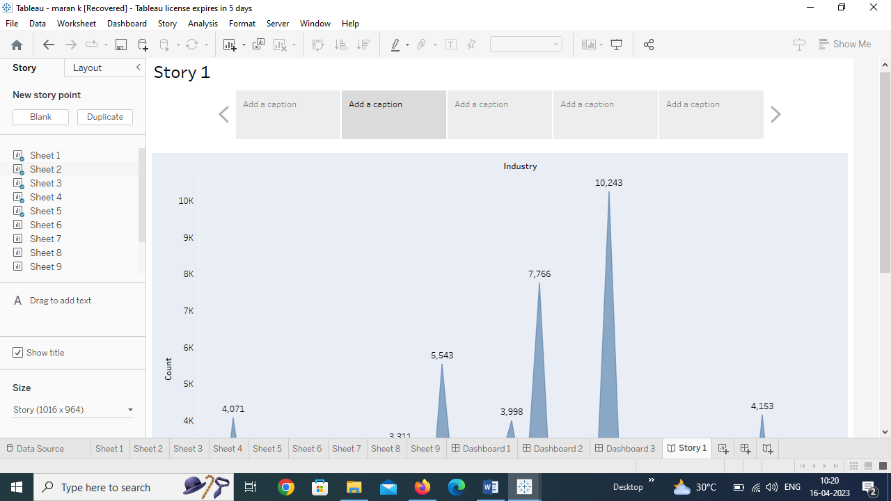

4.ADVANTAGES & DISADAVNTAGES

Advantages of Startup Analysis:

1. Provides strategic direction: Startup analysis can help businesses to understand their target market, identify their competitive advantage, and develop a comprehensive strategy to ensure success.

2. Helps to make informed decisions: Startup analysis provides data-backed information on various aspects of the business, such as market size, competition, and potential revenue, which can be used to make informed decisions about investment, product development, marketing, and other aspects of the business.

3. Helps to set realistic goals: Startup analysis can help businesses to set achievable and realistic goals by leveraging data on market size and demand, competition, and growth potential.

4. Helps to secure funding: A thorough startup analysis can help businesses to secure funding from investors by demonstrating the viability of the project and providing a clear roadmap for growth and success.

Disadvantages of Startup Analysis:

1. How can these drawbacks be mitigated?
2. Conducting a comprehensive startup analysis can be time-consuming and expensive, but there are ways to mitigate its drawbacks.
3. One way to reduce the time and expense of a startup analysis is to focus on the most critical aspects of the project and prioritize the most important data. This can help ensure that the effort put into a startup analysis is worth the investment.
4. Another way to mitigate the risk of over-analyzing is to set clear goals and deadlines for the startup analysis. This can help keep the process focused and on track.
5. Finally, it is important to communicate the findings of the startup analysis and any proposed changes clearly and persuasively. This will help reduce resistance to change and ensure that the results of the startup analysis are implemented effectively.
6. Overall, while there are certainly potential drawbacks to conducting a startup analysis, the potential benefits, such as improved chances of success, can outweigh them..

5.APPLICATION :

1. Customer acquisition and retention: Use startup analysis to study consumer behavior and determine which marketing channels are most effective at acquiring and retaining customers.

2. Pricing: Use startup analysis to determine the most effective pricing strategy for a product or service, based on factors such as market demand, competition, and production costs.

3. Product development: Use startup analysis to assess the feasibility of new products or services, including their potential market demand, production costs, and distribution channels.

4. Sales and revenue growth: Use startup analysis to identify opportunities for sales growth and revenue growth, such as new markets, new products, or new distribution channels.

5. Competitive advantage: Use startup analysis to understand the strengths and weaknesses of competitors and identify ways to gain a competitive advantage.

6. Brand building: Use startup analysis to understand consumer perceptions of a brand and find ways to build brand equity and loyalty.

6.CONCLUSION

Start by defining our objective for the analysis. What are you trying to achieve? What questions do you want to answer? For example, we might want to analyze the success factors for startups in a particular industry or geographic location. And then we Identify the data sources that will help the answer our questions. This might include information on startups funding, revenue, employee count, industry, location, and more. Clean and prepare oour data for analysis in Tableau. and then we Connect to data sources in Tableau. Import our clean data into Tableau. Create data connections and define relationships between tables as needed. And then Create visualizations. Build visualizations that help to understand the data and answer your questions. Examples might include charts showing funding trends over time, maps showing startup density by location, or scatterplots comparing funding levels and revenue. Use Tableau's analysis tools to explore our data and identify trends and insights. Identify any outliers or anomalies in your data that might warrant further investigation. And then we Use our Tableau visualizations to communicate your findings to stakeholders. Create a dashboard or presentation that highlights our key insights and tells a compelling story about our data. Use stakeholder feedback to refine our analysis and improve our visualizations. Iterate on our work to ensure that it meets the needs of our audience and provides valuable insights.

By following these steps, we can use Tableau to conduct a thorough and insightful analysis of startups in our chosen industry or geographic location.

7.FUTURE SCOPE :

The future scope for startup analysis is promising, as the demand for comprehensive and accurate assessments of new projects and business ventures continues to increase. Here are some potential areas of growth for startup analysis:

1. Artificial intelligence and machine learning: With the growing capabilities of artificial intelligence and machine learning, there is potential for these technologies to be applied to startup analysis. This could lead to more efficient data analysis and improved accuracy in identifying potential risks and benefits.
2. Virtual reality and augmented reality: Virtual and augmented reality technologies could be used to create immersive simulations of potential projects, allowing stakeholders to better visualize and understand the feasibility and potential outcomes of a project.
3. Blockchain technology: Blockchain technology could be applied to startup analysis, providing a more secure and transparent way to gather and analyze data and track project progress.
4. Sustainability analysis: As sustainability becomes a growing concern in business, startup analysis could be expanded to include assessments of the environmental and social impact of a project, helping to identify potential risks and opportunities for sustainable practices.
5. Collaboration tools: With the increasing prevalence of remote work and global teams, there is potential for collaboration tools to be integrated into startup analysis, enabling stakeholders to work together more efficiently and effectively.

8.APPENDIX

A. SOURCE CODE

<!DOCTYPE html>

<html lang="en">

<head>

<meta charset="utf-8">

<meta content="width=device-width, initial-scale=1.0" name="viewport">

<title>FlexStart Bootstrap Template - Index</title>

<meta content="" name="description">

<meta content="" name="keywords">

<!-- Favicons -->

<link href="assets/img/favicon.png" rel="icon">

<link href="assets/img/apple-touch-icon.png" rel="apple-touch-icon">

<!-- Google Fonts -->

<link href="https://fonts.googleapis.com/css?family=Open+Sans:300,300i,400,400i,600,600i,700,700i|Nunito:300,300i,400,400i,600,600i,700,700i|Poppins:300,300i,400,400i,500,500i,600,600i,700,700i" rel="stylesheet">

<!-- Vendor CSS Files -->

<link href="assets/vendor/aos/aos.css" rel="stylesheet">

<link href="assets/vendor/bootstrap/css/bootstrap.min.css" rel="stylesheet">

<link href="assets/vendor/bootstrap-icons/bootstrap-icons.css" rel="stylesheet">

<link href="assets/vendor/glightbox/css/glightbox.min.css" rel="stylesheet">

<link href="assets/vendor/remixicon/remixicon.css" rel="stylesheet">

<link href="assets/vendor/swiper/swiper-bundle.min.css" rel="stylesheet">

<!-- Template Main CSS File -->

<link href="assets/css/style.css" rel="stylesheet">

<!-- =======================================================

* Template Name: FlexStart

* Updated: Mar 10 2023 with Bootstrap v5.2.3

* Template URL: https://bootstrapmade.com/flexstart-bootstrap-startup-template/

* Author: BootstrapMade.com

* License: https://bootstrapmade.com/license/

======================================================== -->

</head>

<body>

<!-- ======= Header ======= -->

<header id="header" class="header fixed-top">

<div class="container-fluid container-xl d-flex align-items-center justify-content-between">

<a href="index.html" class="logo d-flex align-items-center">

<img src="assets/img/logo.png" alt="">

<span>StartUP</span>

</a>

<nav id="navbar" class="navbar">

<ul>

<li><a class="nav-link scrollto active" href="index.html">Home</a></li>

<li><a class="nav-link scrollto" href="about.html">About</a></li>

<li><a class="nav-link scrollto" href="story.html">Story</a></li>

<li><a class="nav-link scrollto" href="DASHBOARD DETAIL.html">Dashboard</a></li>

<li><a class="nav-link scrollto" href="contact.html">Contact</a></li>

<li><a class="getstarted scrollto" href="about.html">Get Started</a></li>>

</ul>

<i class="bi bi-list mobile-nav-toggle"></i>

</nav><!-- .navbar -->

</div>

</header><!-- End Header -->

<!-- ======= Hero Section ======= -->

<section id="hero" class="hero d-flex align-items-center">

<div class="container">

<div class="row">

<div class="col-lg-6 d-flex flex-column justify-content-center">

<h1 data-aos="fade-up">indian startup analysis and visualization</h1>

<h2 data-aos="fade-up" data-aos-delay="400">we have analyized and about the startups that are especially in india and approved by indian govt</h2>

<div data-aos="fade-up" data-aos-delay="600">

<div class="text-center text-lg-start">

<a href="#about" class="btn-get-started scrollto d-inline-flex align-items-center justify-content-center align-self-center">

<span>Get Started</span>

<i class="bi bi-arrow-right"></i>

</a>

</div>

</div>

</div>

<div class="col-lg-6 hero-img" data-aos="zoom-out" data-aos-delay="200">

<img src="assets/img/hero-img.png" class="img-fluid" alt="">

</div>

</div>

</div>

</section><!-- End Hero -->

<section id="about" class="about">

<div class="container" data-aos="fade-up">

<div class="row gx-0">

<div class="col-lg-6 d-flex flex-column justify-content-center" data-aos="fade-up" data-aos-delay="200">

<div class="content">

<h3>Who We Are</h3>

<h2>we analyze startup company data .</h2>

<p>

Grow your sales with all-in-one prospecting solutions powered by the leader in private-company data.

</p>

<div class="text-center text-lg-start">

<a href="#" class="btn-read-more d-inline-flex align-items-center justify-content-center align-self-center">

<span>Read More</span>

<i class="bi bi-arrow-right"></i>

</a>

</div>

</div>

</div>

<div class="col-lg-6 d-flex align-items-center" data-aos="zoom-out" data-aos-delay="200">

<img src="assets/img/about.jpg" class="img-fluid" alt="">

</div>

</div>

</div>

</section>

<section id="services" class="services">

<div class="container" data-aos="fade-up">

<header class="section-header">

<h2>Story</h2>

<p>ANALYSIS OF STARTUP COMPANY BY YEAR AND COUNT ETC.. </p>

</header>

<div class='tableauPlaceholder' id='viz1680959606127' style='position: relative'><noscript><a href='#'><img alt='INNOVATION : STARTUP ANALYSIS ' src='https:&#47;&#47;public.tableau.com&#47;static&#47;images&#47;st&#47;startupcompanies_16809460832610&#47;Story1&#47;1_rss.png' style='border: none' /></a></noscript><object class='tableauViz' style='display:none;'><param name='host_url' value='https%3A%2F%2Fpublic.tableau.com%2F' /> <param name='embed_code_version' value='3' /> <param name='site_root' value='' /><param name='name' value='startupcompanies_16809460832610&#47;Story1' /><param name='tabs' value='no' /><param name='toolbar' value='yes' /><param name='static_image' value='https:&#47;&#47;public.tableau.com&#47;static&#47;images&#47;st&#47;startupcompanies_16809460832610&#47;Story1&#47;1.png' /> <param name='animate_transition' value='yes' /><param name='display_static_image' value='yes' /><param name='display_spinner' value='yes' /><param name='display_overlay' value='yes' /><param name='display_count' value='yes' /><param name='language' value='en-US' /></object></div> <script type='text/javascript'> var divElement = document.getElementById('viz1680959606127'); var vizElement = divElement.getElementsByTagName('object')[0]; vizElement.style.width='1016px';vizElement.style.height='991px'; var scriptElement = document.createElement('script'); scriptElement.src = 'https://public.tableau.com/javascripts/api/viz_v1.js'; vizElement.parentNode.insertBefore(scriptElement, vizElement); </script>

</section>

<section id="portfolio" class="portfolio">

<div class="container" data-aos="fade-up">

<header class="section-header">

<h2>Dashboard</h2>

<p>Check our latest work</p>

</header>

<div class='tableauPlaceholder' id='viz1680955743310' style='position: relative'><noscript><a href='#'><img alt='Dashboard 1 ' src='https:&#47;&#47;public.tableau.com&#47;static&#47;images&#47;st&#47;startup_16809457872980&#47;Dashboard1&#47;1_rss.png' style='border: none' /></a></noscript><object class='tableauViz' style='display:none;'><param name='host_url' value='https%3A%2F%2Fpublic.tableau.com%2F' /> <param name='embed_code_version' value='3' /> <param name='site_root' value='' /><param name='name' value='startup_16809457872980&#47;Dashboard1' /><param name='tabs' value='no' /><param name='toolbar' value='yes' /><param name='static_image' value='https:&#47;&#47;public.tableau.com&#47;static&#47;images&#47;st&#47;startup_16809457872980&#47;Dashboard1&#47;1.png' /> <param name='animate_transition' value='yes' /><param name='display_static_image' value='yes' /><param name='display_spinner' value='yes' /><param name='display_overlay' value='yes' /><param name='display_count' value='yes' /><param name='language' value='en-US' /></object></div> <script type='text/javascript'> var divElement = document.getElementById('viz1680955743310'); var vizElement = divElement.getElementsByTagName('object')[0]; if ( divElement.offsetWidth > 800 ) { vizElement.style.width='1000px';vizElement.style.height='827px';} else if ( divElement.offsetWidth > 500 ) { vizElement.style.width='1000px';vizElement.style.height='827px';} else { vizElement.style.width='100%';vizElement.style.height='1327px';} var scriptElement = document.createElement('script'); scriptElement.src = 'https://public.tableau.com/javascripts/api/viz_v1.js'; vizElement.parentNode.insertBefore(scriptElement, vizElement); </script>

</Section>

<!-- ======= Clients Section ======= -->

<section id="clients" class="clients">

<div class="container" data-aos="fade-up">

<header class="section-header">

<h2>Our Clients</h2>

<p>100+ COMPANIES </p>

</header>

<div class="clients-slider swiper">

<div class="swiper-wrapper align-items-center">

<div class="swiper-slide"><img src="assets/img/clients/client-1.png" class="img-fluid" alt=""></div>

<div class="swiper-slide"><img src="assets/img/clients/client-2.png" class="img-fluid" alt=""></div>

<div class="swiper-slide"><img src="assets/img/clients/client-3.png" class="img-fluid" alt=""></div>

<div class="swiper-slide"><img src="assets/img/clients/client-4.png" class="img-fluid" alt=""></div>

<div class="swiper-slide"><img src="assets/img/clients/client-5.png" class="img-fluid" alt=""></div>

<div class="swiper-slide"><img src="assets/img/clients/client-6.png" class="img-fluid" alt=""></div>

<div class="swiper-slide"><img src="assets/img/clients/client-7.png" class="img-fluid" alt=""></div>

<div class="swiper-slide"><img src="assets/img/clients/client-8.png" class="img-fluid" alt=""></div>

</div>

<div class="swiper-pagination"></div>

</div>

</div>

</section><!-- End Clients Section -->

<!-- ======= Recent Blog Posts Section ======= -->

<section id="recent-blog-posts" class="recent-blog-posts">

<div class="container" data-aos="fade-up">

<header class="section-header">

<h2>NEWS</h2>

<p>RECENT NEWS ABOUT US</p>

</header>

<div class="row">

<div class="col-lg-4">

<div class="post-box">

<div class="post-img"><img src="assets/img/blog/blog-1.jpg" class="img-fluid" alt=""></div>

<span class="post-date">Tue, September 15</span>

<h3 class="post-title">Global news media startup Semafor open to an India partner for

launching local edition</h3>

<a href="https://economictimes.indiatimes.com/tech/technology/global-news-media-startup-semafor-open-to-an-india-partner-for-launching-local-edition/articleshow/93646374.cms" class="readmore stretched-link mt-auto"><span>Read More</span><i class="bi bi-arrow-right"></i></a>

</div>

</div>

<div class="col-lg-4">

<div class="post-box">

<div class="post-img"><img src="assets/img/blog/blog-2.jpg" class="img-fluid" alt=""></div>

<span class="post-date">Fri, August 28</span>

<h3 class="post-title">Robotics data startup led by former Amazon drone engineers emerges

from stealth, raises $4.8M</h3>

<a href="https://www.geekwire.com/2023/robotics-data-startup-led-by-former-amazon-drone-engineers-emerges-from-stealth-with-4-8m/" class="readmore stretched-link mt-auto"><span>Read More</span><i class="bi bi-arrow-right"></i></a>

</div>

</div>

<div class="col-lg-4">

<div class="post-box">

<div class="post-img"><img src="assets/img/blog/blog-3.jpg" class="img-fluid" alt=""></div>

<span class="post-date">Mon, July 11</span>

<h3 class="post-title">Indian Startup Layoff Tracker: 24,250+ Employees Laid Off Amid

Startup Funding Winter</h3>

<a href="https://inc42.com/features/indian-startup-layoffs-tracker/" class="readmore stretched-link mt-auto"><span>Read More</span><i class="bi bi-arrow-right"></i></a>

</div>

</div>

</div>

</div>

</section><!-- End Recent Blog Posts Section -->

<!-- ======= Contact Section ======= -->

<section id="contact" class="contact">

<div class="container" data-aos="fade-up">

<header class="section-header">

<h2>Contact</h2>

<p>Contact Us</p>

</header>

<div class="row gy-4">

<div class="col-lg-6">

<div class="row gy-4">

<div class="col-md-6">

<div class="info-box">

<i class="bi bi-geo-alt"></i>

<h3>Address</h3>

<p>B.SC PHYSICS A.M JAIN,<br>MENNAMBAKKAM</p>

</div>

</div>

<div class="col-md-6">

<div class="info-box">

<i class="bi bi-telephone"></i>

<h3>Call Us</h3>

<p>+91 9790776525<br>+91 8608420119</p>

</div>

</div>

<div class="col-md-6">

<div class="info-box">

<i class="bi bi-envelope"></i>

<h3>Email Us</h3>

<p>MARANK1105@GMAIL.COM</P>

</div>

</div>

<div class="col-md-6">

<div class="info-box">

<i class="bi bi-clock"></i>

<h3>Open Hours</h3>

<p>Monday - Friday<br>9:00AM - 05:00PM</p>

</div>

</div>

</div>

</div>

<div class="col-lg-6">

<form action="forms/contact.php" method="post" class="php-email-form">

<div class="row gy-4">

<div class="col-md-6">

<input type="text" name="name" class="form-control" placeholder="Your Name" required>

</div>

<div class="col-md-6 ">

<input type="email" class="form-control" name="email" placeholder="Your Email" required>

</div>

<div class="col-md-12">

<input type="text" class="form-control" name="subject" placeholder="Subject" required>

</div>

<div class="col-md-12">

<textarea class="form-control" name="message" rows="6" placeholder="Message" required></textarea>

</div>

<div class="col-md-12 text-center">

<div class="loading">Loading</div>

<div class="error-message"></div>

<div class="sent-message">Your message has been sent. Thank you!</div>

<button type="submit">Send Message</button>

</div>

</div>

</form>

</div>

</div>

</div>

</section><!-- End Contact Section -->

</main><!-- End #main -->

<!-- ======= Footer ======= -->

<footer id="footer" class="footer">

<div class="footer-newsletter">

<div class="container">

<div class="row justify-content-center">

<div class="col-lg-12 text-center">

<h4>Our Newsletter</h4>

<p>Receive updates, news and deals</p>

</div>

<div class="col-lg-6">

<form action="" method="post">

<input type="email" name="email"><input type="submit" value="Subscribe">

</form>

</div>

</div>

</div>

</div>

<div class="footer-top">

<div class="container">

<div class="row gy-4">

<div class="col-lg-5 col-md-12 footer-info">

<a href="index.html" class="logo d-flex align-items-center">

<img src="assets/img/logo.png" alt="">

<span>SATRTUP</span>

</a>

<p>A startup company is a newly formed business with particular momentum behind it based on perceived demand for its product or service. The intention of a startup is to grow rapidly as a result of offering something that addresses a particular market gap..</p>

<div class="social-links mt-3">

<a href="#" class="twitter"><i class="bi bi-twitter"></i></a>

<a href="#" class="facebook"><i class="bi bi-facebook"></i></a>

<a href="#" class="instagram"><i class="bi bi-instagram"></i></a>

<a href="#" class="linkedin"><i class="bi bi-linkedin"></i></a>

</div>

</div>

<div class="col-lg-2 col-6 footer-links">

<h4>Useful Links</h4>

<ul>

<li><i class="bi bi-chevron-right"></i> <a href="#">Home</a></li>

<li><i class="bi bi-chevron-right"></i> <a href="#">About us</a></li>

<li><i class="bi bi-chevron-right"></i> <a href="#">Services</a></li>

<li><i class="bi bi-chevron-right"></i> <a href="#">Terms of service</a></li>

<li><i class="bi bi-chevron-right"></i> <a href="#">Privacy policy</a></li>

</ul>

</div>

<div class="col-lg-2 col-6 footer-links">

<h4>Our Services</h4>

<ul>

<li><i class="bi bi-chevron-right"></i> <a href="#">Web Design</a></li>

<li><i class="bi bi-chevron-right"></i> <a href="#">Web Development</a></li>

<li><i class="bi bi-chevron-right"></i> <a href="#">Product Management</a></li>

<li><i class="bi bi-chevron-right"></i> <a href="#">Marketing</a></li>

<li><i class="bi bi-chevron-right"></i> <a href="#">Graphic Design</a></li>

</ul>

</div>

<div class="col-lg-3 col-md-12 footer-contact text-center text-md-start">

<h4>Contact Us</h4>

<p>

B.SC PHYSICS A.M JAIN <br>

MENNAMBAKKAM<br>

CHENNAI <br><br>

<strong>Phone:</strong> +91 9790776525<br>

<strong>Email:</strong> MARANK1105@GMAIL.COM<br>

</p>

</div>

</div>

</div>

</div>

<div class="container">

<div class="copyright">

&copy; Copyright <strong><span>SATRTUP</span></strong>. All Rights Reserved

</div>

<div class="credits">

<!-- All the links in the footer should remain intact. -->

<!-- You can delete the links only if you purchased the pro version. -->

<!-- Licensing information: https://bootstrapmade.com/license/ -->

<!-- Purchase the pro version with working PHP/AJAX contact form: https://bootstrapmade.com/flexstart-bootstrap-startup-template/ -->

Designed by <a href="https://bootstrapmade.com/">BootstrapMade</a>

</div>

</div>

</footer><!-- End Footer -->

<a href="#" class="back-to-top d-flex align-items-center justify-content-center"><i class="bi bi-arrow-up-short"></i></a>

<!-- Vendor JS Files -->

<script src="assets/vendor/purecounter/purecounter_vanilla.js"></script>

<script src="assets/vendor/aos/aos.js"></script>

<script src="assets/vendor/bootstrap/js/bootstrap.bundle.min.js"></script>

<script src="assets/vendor/glightbox/js/glightbox.min.js"></script>

<script src="assets/vendor/isotope-layout/isotope.pkgd.min.js"></script>

<script src="assets/vendor/swiper/swiper-bundle.min.js"></script>

<script src="assets/vendor/php-email-form/validate.js"></script>

<!-- Template Main JS File -->

<script src="assets/js/main.js"></script>

</body>

</html>